**PRACTICAL 1.A**

Create a program that asks the user to enter their name and their age. Print out a message addressed to them that tells them the year that they will turn 100 years old.

**CODE**

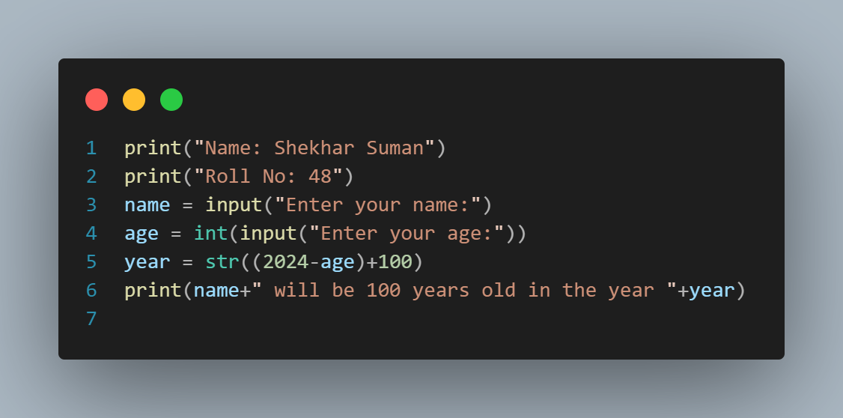

**OUTPUT**

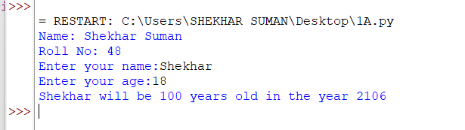

**PRACTICAL 1.B**

Enter the number from the user and depending on whether the number is even or odd, print out an appropriate message to the user.

**CODE**

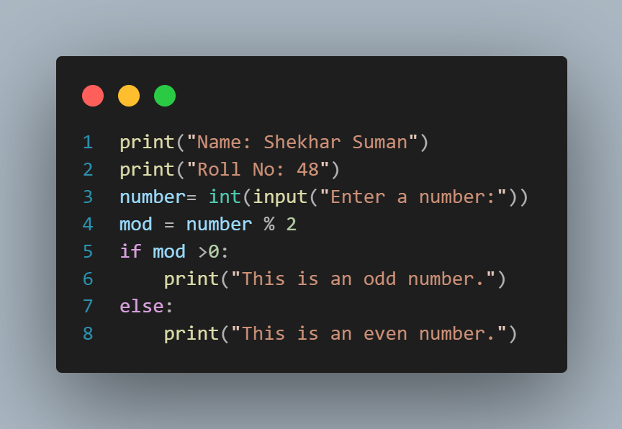

**OUTPUT**

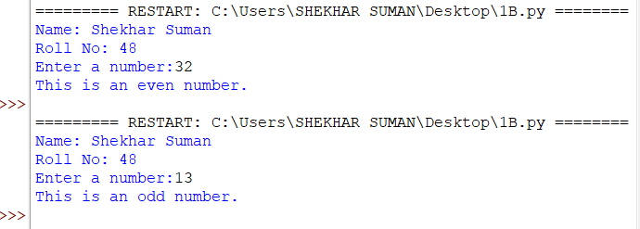

**PRACTICAL 1.C**

Write a program to generate the Fibonacci Series.

**CODE**

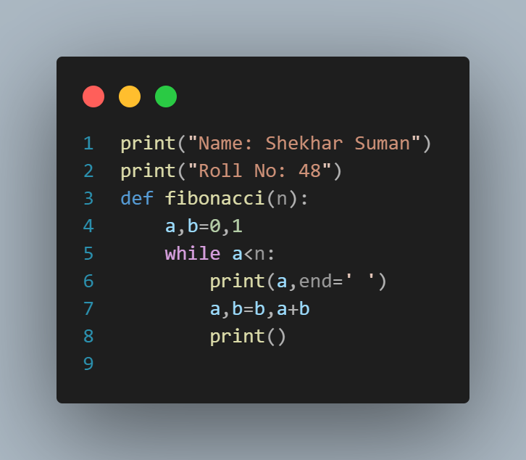

**OUTPUT**

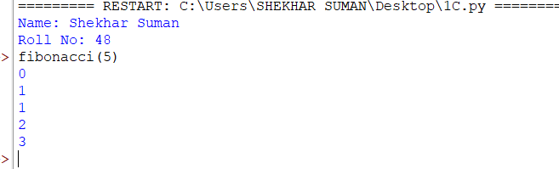

**PRACTICAL 1.D**

Write a function that reverse the user defined value.

**CODE**

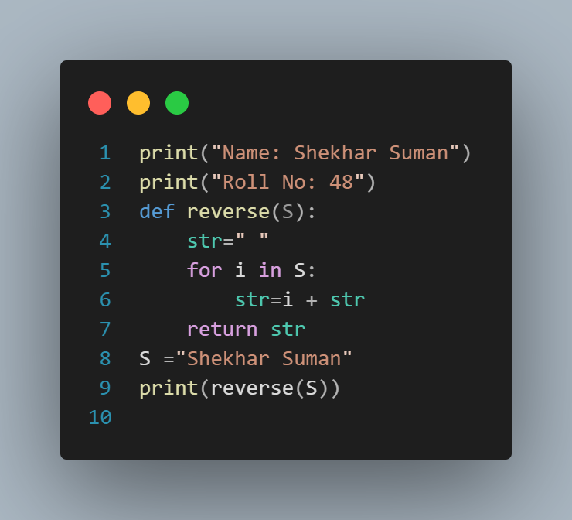

**OUTPUT**

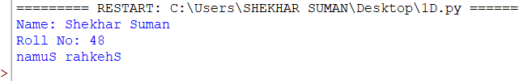

**PRACTICAL 1.E**

Write a function to check the input value is Armstrong and also write the function for Palindrome.

**CODE**

Armstrong

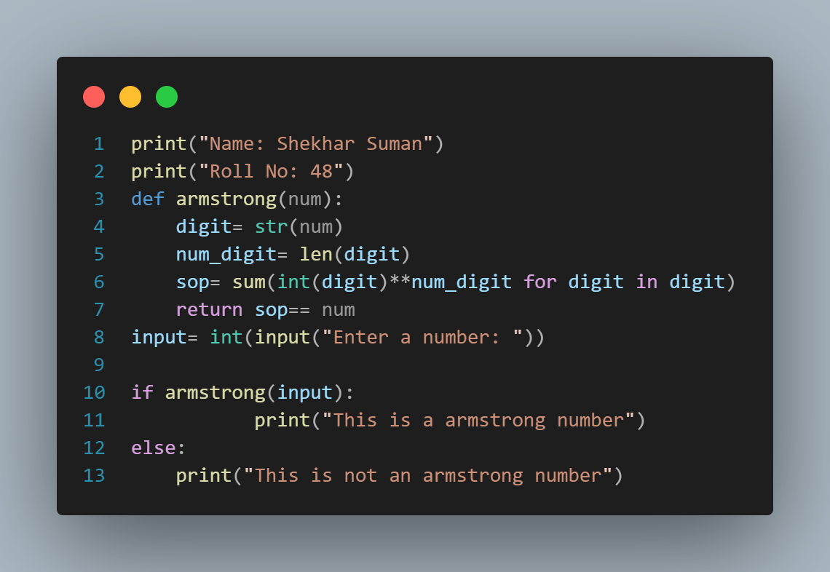

**OUTPUT**

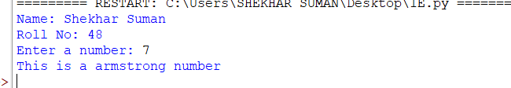

Palindrome User Defined

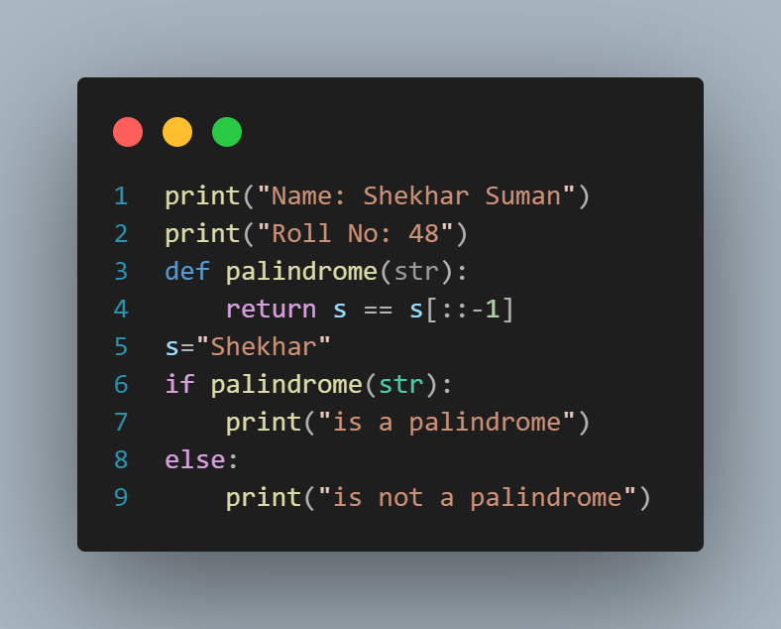

**OUTPUT**

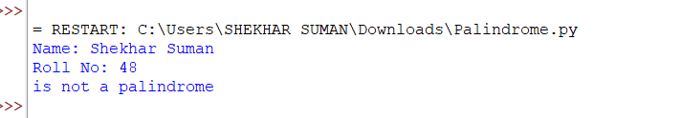

Palindrome User Input

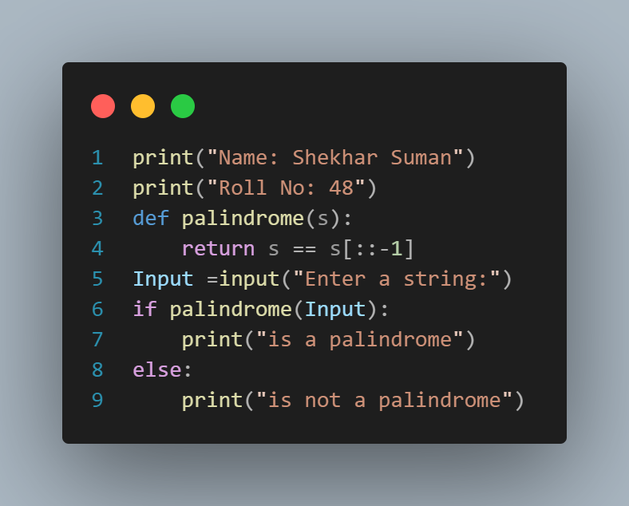

**OUTPUT**

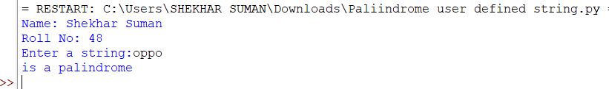

**PRACTICAL 1.F**

Write a recursive function to print the factorial for a given number.

**CODE**

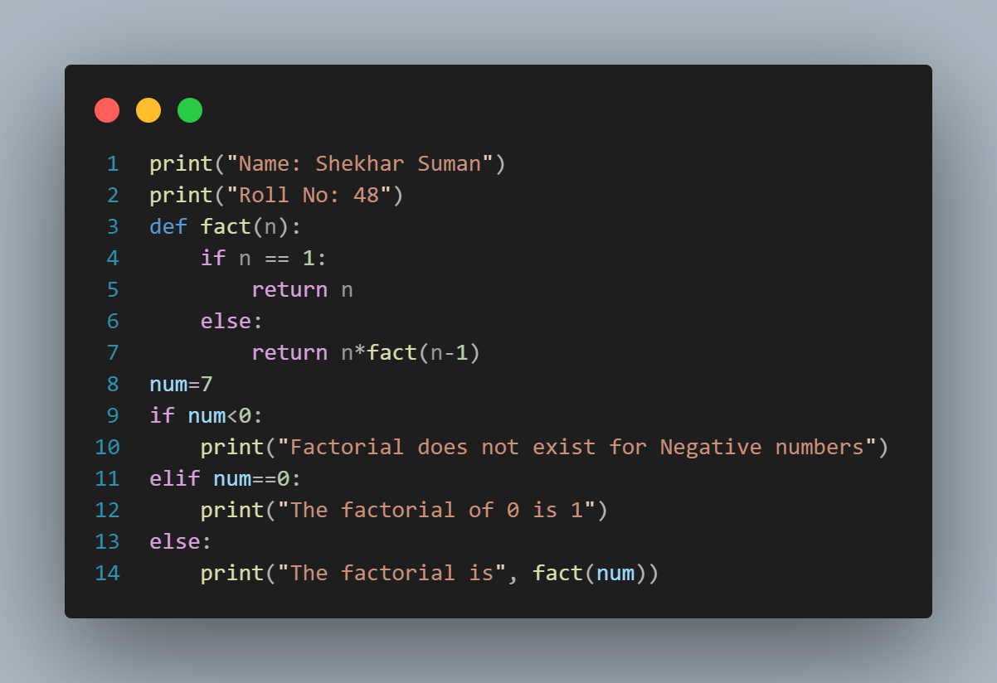

**OUTPUT**

